Chapter 3, Problem 18.

Determine the node voltages in the circuit in Fig. 3.67 using nodal analysis.
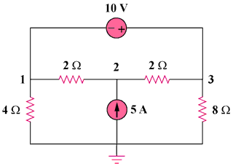

30 V

15 A

Figure 3.67
For Prob. 3.18.

